|  |  |
| --- | --- |
| **HOME PAGE** | |
| Nome LAB | ??? |
| Descrizione ricerca | My research interests are based principally on the study of the dynamic and structural properties of paramagnetic metal complexes with potential applications in MRI and Molecular Imaging. Particular attention is devoted to their interactions with biological macromolecular systems either in *in vitro* cellular and *in vivo* animal models. In recent years I’ve been engaged in the development of new MRI contrast agents endowed with high specificity towards particular target molecules for the detection of tumour cells as well as in the study of new probes which answer is responsive of a particular bio-parameter of interest. Presently, my main research activity concerns the study of phenomena associated with the problem of Gd retention in the body upon repeated administrations of Gd-based Contrast Agents. |
| Foto personale | Nome file: cognome.jpg |
| Linee di ricerca | Fast Field Cycling Relaxometry in vitro and in vivo  Gadolinium Retention in the body |
| Immagini per linee di ricerca | Nome files (figure_research_overview1.jpg, figure_research_overview_2.jpg, ...) |
| Upcoming Events | Indicare la data di inizio dell’evento, la descrizione con il link [www.sito/dell’/evento] con evidenziato in giallo la parola o il testo relativo al link e eventuali figure (figure_events1.jpg, figure_events2.jpg, ...) |
| News | Desrizione delle news, se richiesto, riportare il link come [www.link/della/news]con evidenziato in giallo la parola o il testo relativo al link e eventuali figure (figure_news1.jpg, figure_news2.jpg, …) |
|  |  |
| **RESEARCH OVERVIEW** | |
| Linee di ricerca | Study of the dynamic and structural properties of paramagnetic metal complexes with potential applications in MRI and Molecular Imaging |
|  |  |
| **RESEARCH LINE #1** | |
| Titolo generale | High Relaxivity Gd-complexes |
| Introduzione generale | The sensitivity issue of MRI technique is related the intrinsic Relaxivity of a given Contrast Agent. The chemists have to design systems endowed with structural and dynamic properties that lead to optimized values for those parameters that are relevant for a given contrast enhancing mechanism. Much work has been done and is ongoing to design structures with high relaxivity. |
| attività specifica/specifiche | The efficiency of a given paramagnetic complex is closely  related to its relaxivity. Relaxivity is the result of a complex interplay between the paramagnetic center’s structural, dynamic, and electronic properties. Good estimates of the determinants of  the relaxivity of a given paramagnetic complex can be obtained from the analysis of relaxivity data as a function of the applied magnetic field (NMRD profiles). High relaxivities can be attained, at the clinical field strength of 0.5-1.5 T, by lengthening the  molecular reorientational time, *τ*R. Therefore, macromolecular  systems were addressed by either the covalent or noncovalent  binding of paramagnetic chelates to slowly moving substrates [Gianolio E. et al 2014, doi: 10.1007/s00775-014-1111-z.] Another opportunity to increase relaxivity is related to the use of bis-hydrated, but still highly-stable, Gd-complexes.[Vagner A et al. 2016 doi: 10.1039/c6cc04753j] |
|  | |
| **RESEARCH LINE #2** | |
| Titolo generale | Relaxometric Methods for medical/biological issues |
| Introduzione generale | This research line relies on the fact that simple and cheap relaxometric methods can be set-up in order to answer to particular medical or biological needs. The main advantage of the relaxometric methods is that the measure of the observed relaxation rate is fast and straightforward and several types of relaxometer are commercially available at easily affordable costs. |
| attività specifica/specifiche | **Example 1:** **Relaxometric method for the re-evaluation of the water exchange lifetime across red blood cell membrane**  The method for the determination of RBC membrane permeability to water is based on the measurement of T1 or T2 of a RBC suspension in the presence of a paramagnetic Gd-complex ions in the suspending medium.  In principle, the presence of of the paramagnetic complex make the overallwater proton relaxation curve resolvable into two components, namely, a fast component corresponding to water protons in the extracellular, Gddoped, compartment and a slow component corresponding to the inner cell compartment whose relaxation is modulated by the rate of water exchange across the cellular membrane. The experimental work-up relies on the fitting of the experimental data to a theoretical bi-exponential curve calculated for the effect of two-site exchange.  [Gianolio E et al 2016, doi: 10.1016/j.bbamem.2015.12.029]  **Example 2:** R**elaxometric method for the assessment of**  **intestinal permeability based on the oral administration of gadolinium-based MRI contrast agents**  The extent of urine excretion of the orally injested GBCAs is taken as a reporter to detect intestinal barrier dysfunction. The method proposed here for the quantitative detection of Gd-based probes in urine is very easy to implement because the paramagnetism of the Gd3+ ions causes a decrease in the  water proton relaxation time (T1) which is proportional to the concentration of the agent. The measurement of the longitudinal relaxation rate (R1=1/T1) can be carried out on any NMR spectrometer or cheaper relaxometer with a semi-automatic procedure which takes 1–5 min, depending on the concentration  of the paramagnetic probe in urine. As no sample preparation or external calibration is required, the T1-based method results in a much faster procedure with respect to the ‘gold standard’ HPLC or HPLC/MS analysis. The Gd complexes are relatively large molecules (MW, 500–1000 Da), which are highly hydrophilic and are not degraded by colonic bacteria, and so are excellent candidates to report membrane damage along the entire intestinal tract.  [Gianolio E et al. 2016 DOI: 10.1002/nbm.3471] |
|  |  |
| **RESEARCH LINE #3** | |
| Titolo generale | Gd retention in the body |
| Introduzione generale | Recently, several studies have shown increased signal intensity on unenhanced T1-weighted MR images in some brain regions in patients with normal renal function who had previously  received multiple doses of GBCAs. The observed hyperintense signal has been associated with the retention of small amounts of gadolinium in the brain. There has been evidence that both linear and macrocyclic GBCAs can yield detectable gadolinium traces  in the brain, with linear neutral agents leaving greater quantities. |
| attività specifica/specifiche | **Example 1: Assessment of the Amounts of Insoluble Gadolinium-containing Species and Intact Gadolinium Complexes after Repeated**  **Administration of Gadolinium-based Contrast Agents**  The purpose of this study was to evaluate the speciation of gadolinium containing  Species in the brain after multiple administrations of gadodiamide and gadoteridol and to quantify the amount of intact gadolinium complexes and insoluble gadolinium-containing species. While the entire fraction of retained  gadolinium was in the form of the intact parent complex in animals treated with gadoteridol, the majority of retained gadolinium was in the form of insoluble species and, in part, of a macromolecular system endowed with very high relaxivity in animals treated with gadodiamide.  [Gianolio E et al 2017 doi: 10.1148/radiol.2017162857]  **Example 2:** **Insights on the Role of Metal Complex Stability by Comparing Metal Uptake in Murine Tissues Upon the Concomitant Administration of Lanthanum- and Gadolinium-DTPA**  The aim of the study was to explore the role of the stability of metal complexes in the processes that lead to the metal retention in the brain and other tissues of mice administered with lanthanides-based contrast agents. This issue was tackled by the simultaneous injection of Gd- DTPA and La-DTPA, which have the same charge and structure but differ in their thermodynamic stability by 3 orders of magnitude.  [Di Gregorio E et al 2017 doi: 10.1097/RLI.0000000000000423] |
| **GROUP** | |
| Foto PI | Nome file: cognome.jpg (stessa foto usata in home) + CV (file pdf) |
| Foto membri (PhD, post-doc) | Nome file: cognome.jpg |
| Info sui membri | Enza Di Gregorio  Andrea Barale |
| Descrizione progetto ricerca | Breve descrizione dell’attività di ricerca di ciascun membro |
| Sezione alumni | Chiara Furlan |
|  |  |
| **PUBLICATIONS** | |
| Goggle scholar | Link vostra pagina su google Scholar |
|  |  |
| **CONTACTS** | |
| Numero telefono | 0116706475 |

**HOME PAGE**



**RESEARCH OVERVIEW**

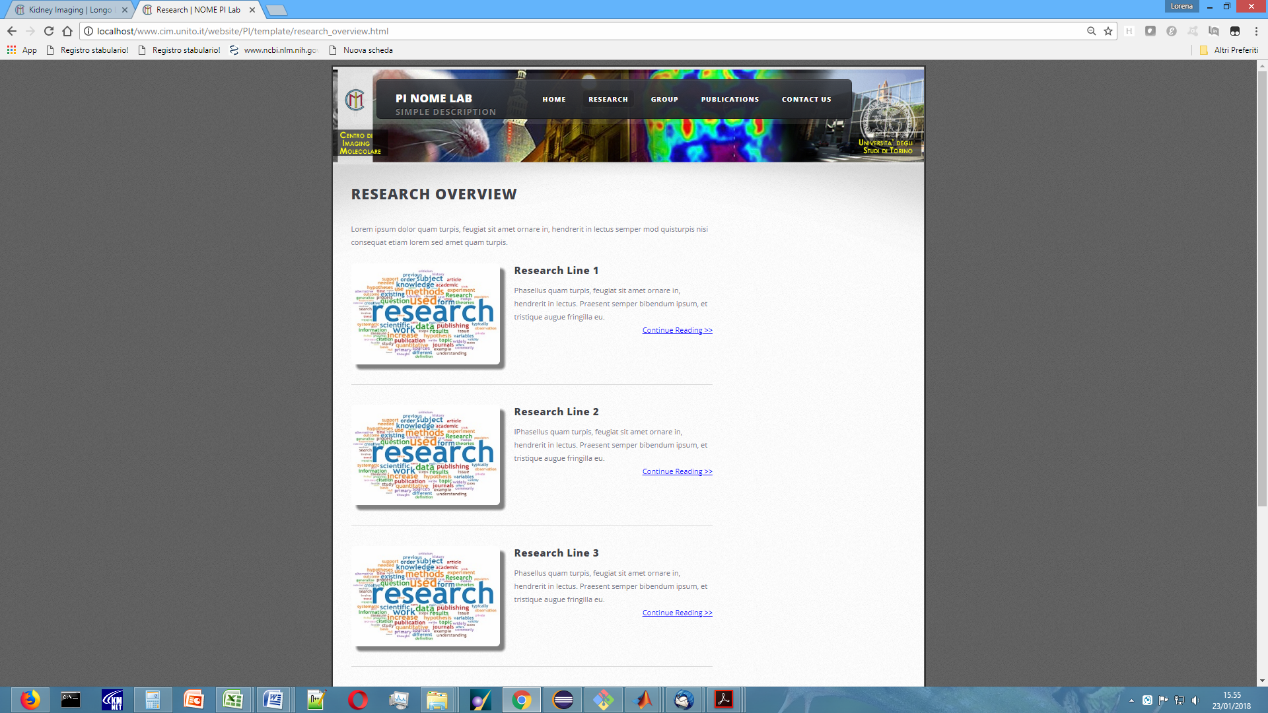

**RESEARCH LINE #1, #2, ...**

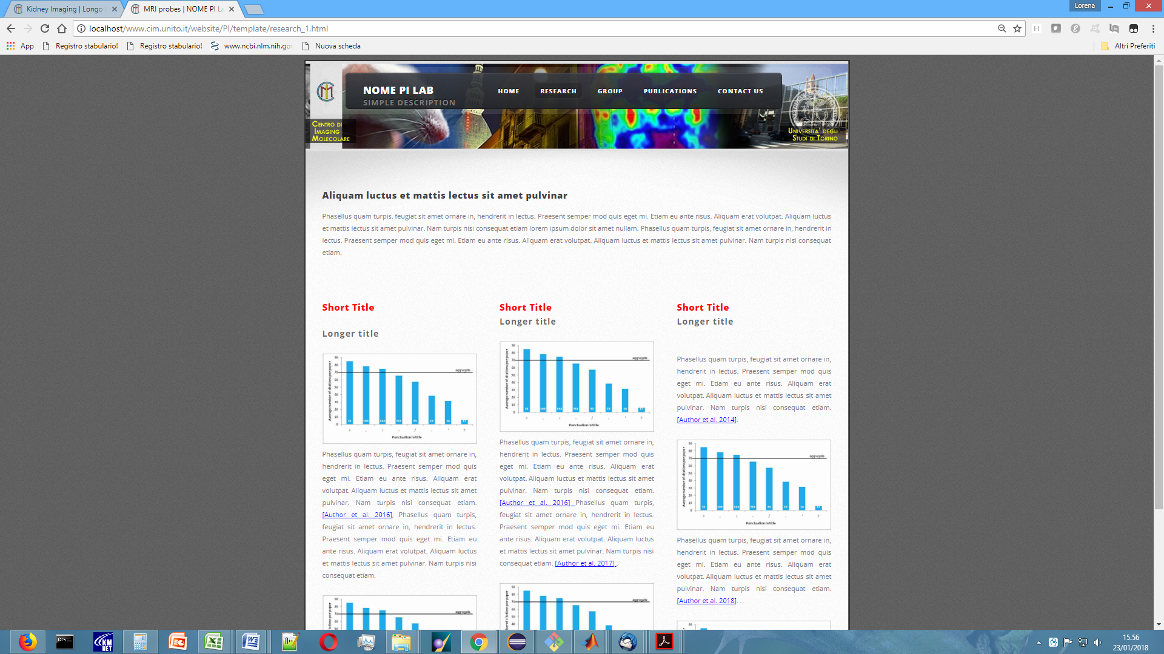

**GROUP**

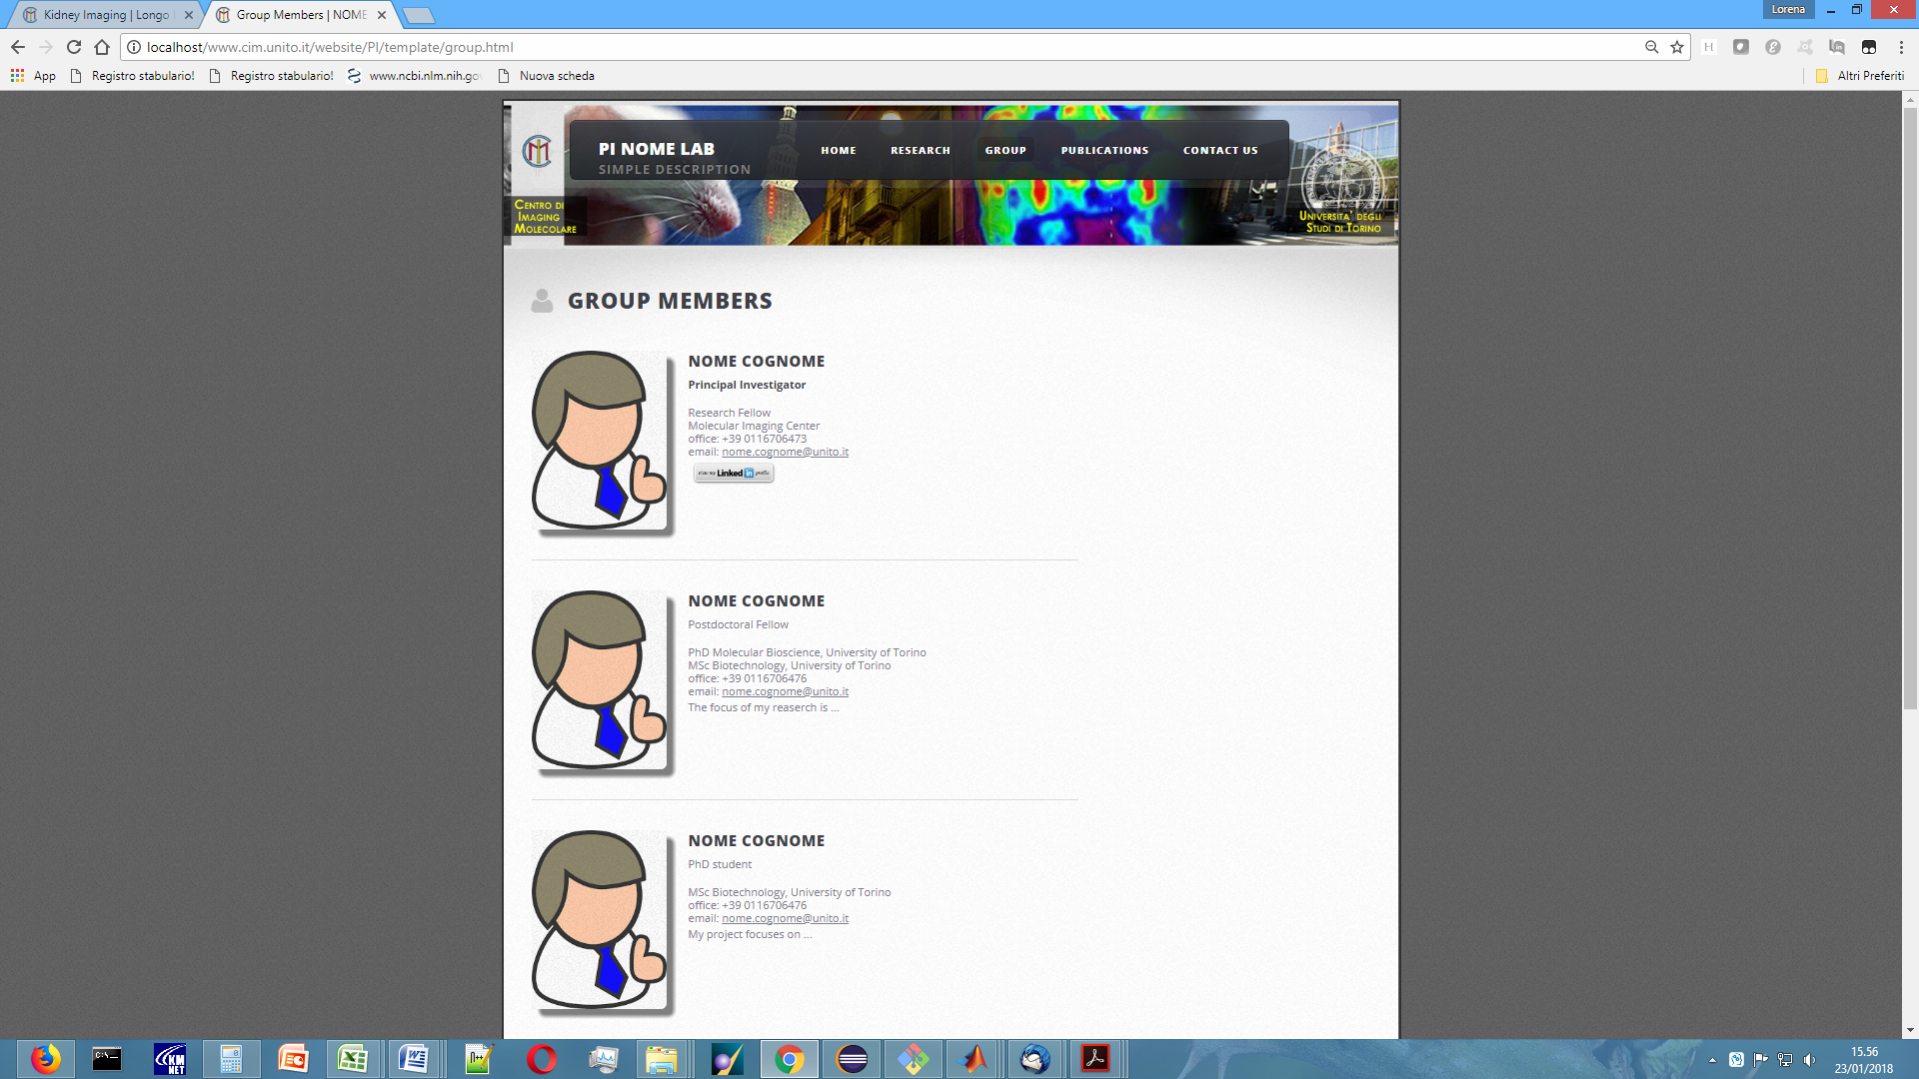

**PUBLICATIONS**

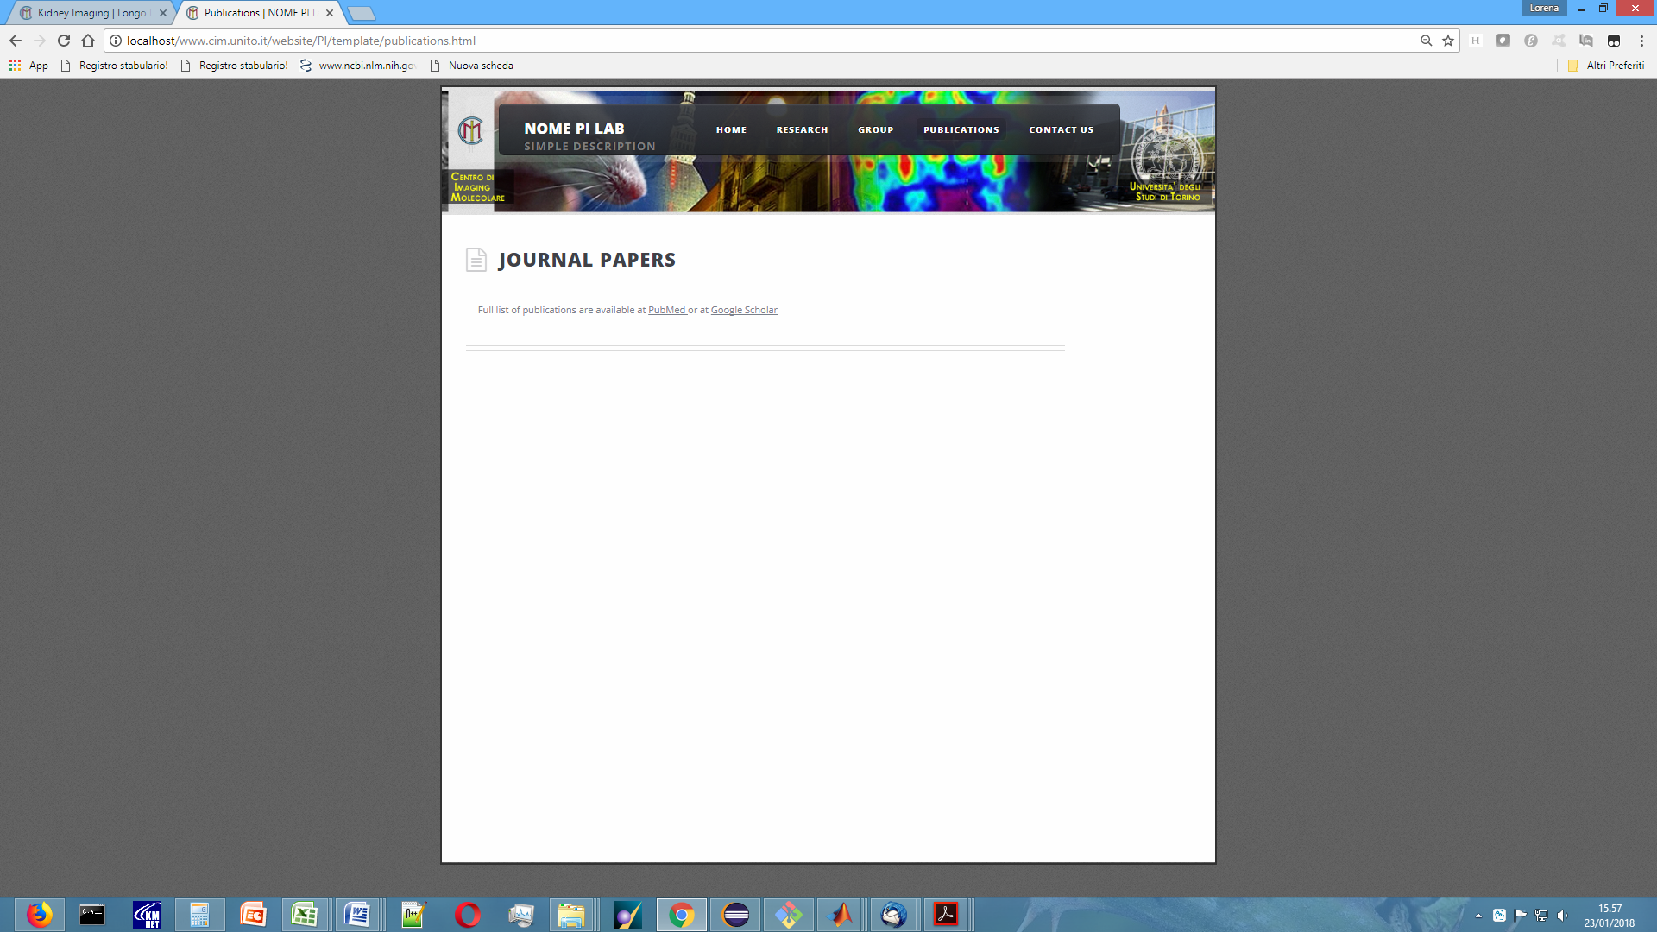

**CONTACT US**

